Patient key number: . . . .

Surgical details
2. Details surgical procedure
Yes (physical); Yes (remote/online); No
ASA classification (1-3)
- 1 = Fit & Healthy
- 2 = Some illness, normal activity
- 3 = Illness, minimal restriction
Date of surgery
Last name(s) of (all) operating surgeon(s) (in training) (";" between them)
Presence trained Right surgeon(s) (joined phase 3: the training sessions in September/October) | Yes (1 of them); Yes (2, both); No
Proctoring

Location of the colon tumour (see figure 1)
Figure 1:

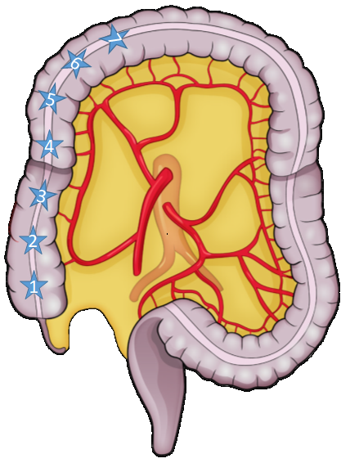

Location of transection colon (see figure 2)
Figure 2:

Laparoscopic or robot-assisted?
Conversion to open abdominal surgery?
Timing
Within 30 minutes/after 30 minutes
Yes/no
Type of conversion
Reactive/preemptive
Total blood loss (cc)  Yes/no |  |  | cc
Intra-operative blood transfusion
Total surgical procedure time in minutes (defined as from incision to last stitch) |  |  | min
Yes/no
ICG applied?
Change of management due to ICG?

Yes/no
Additional resection performed?
Yes/no

Please specify what additional resection was performed

3. Way of working
Pressure pneumoperitoneum  Supine, French, Lithotomy using stirrups, other |  |  | mmHg
Patient position
Supine = patient is laying on the back with legs parallel.
If other, please specify:
French = supine split-leg position.
How many trocars?
Trocar |  | 5, 7, 10, 11, 12 mm  1-7
 | Size
 | Location
5, 7, 10, 11, 12 mm
Umbilical, midline supraumbilical, right lower quadrant, left lower quadrant, right upper quadrant, left upper quadrant, suprapubic, level of umbilicus left, level of umbilicus right, other
If other, please specify:
Umbilical, midline supraumbilical, right lower quadrant, left lower quadrant, right upper quadrant, left upper quadrant, suprapubic, level of umbilicus left, level of umbilicus right, other
If other, please specify:
Trocar
Size
Location

Umbilical, midline supraumbilical, right lower quadrant, left lower quadrant, right upper quadrant, left upper quadrant, suprapubic, level of umbilicus left, level of umbilicus right, other
If other, please specify:
5, 7, 10, 11, 12 mm
Trocar
Size
Location
5, 7, 10, 11, 12 mm
Umbilical, midline supraumbilical, right lower quadrant, left lower quadrant, right upper quadrant, left upper quadrant, suprapubic, level of umbilicus left, level of umbilicus right, other
If other, please specify:
Trocar
Size
Location

Umbilical, midline supraumbilical, right lower quadrant, left lower quadrant, right upper quadrant, left upper quadrant, suprapubic, level of umbilicus left, level of umbilicus right, other
If other, please specify:
5, 7, 10, 11, 12 mm
Trocar
Size
Location

5, 7, 10, 11, 12 mm
Umbilical, midline supraumbilical, right lower quadrant, left lower quadrant, right upper quadrant, left upper quadrant, suprapubic, level of umbilicus left, level of umbilicus right, other
If other, please specify:
Trocar
Size
Location

Umbilical, midline supraumbilical, right lower quadrant, left lower quadrant, right upper quadrant, left upper quadrant, suprapubic, level of umbilicus left, level of umbilicus right, other
If other, please specify:
Trocar
 | Size | 5, 7, 10, 11, 12 mm
 | Location
Medial to lateral (through the ileal mesentery), lateral to medial, caudal to cranial (subileal), cranial to caudal

Surgical approach
Is visualization and dissection of the anterior aspect of the superior mesenteric vein (SMV) both proximal and distal to the origin of the ileocolic vessels performed before ligation? | Yes/no
Please explain why this was not performed

Is Henle identified and dissected?
Yes/no
Please explain why this was not performed

Intracorporeal, extracorporeal
Anastomosis
Isoperistaltic, antiperistaltic
Stapled, handsewn
Left lower quadrant, Transverse, Pfannenstiel, Right lower quadrant, Umbilical (midline), other
If other, please specify:
Extraction site
Stitches, hemostatic agent, reconstruction with vascular surgery
4. Intraoperative complications
Bleeding | Ileocolic vessels, Superior mesenteric vein, Superior mesenteric artery, Middle colic vessels, Henles trunk, (Superior) right colic vein, other  If other, please specify:
Yes/no
If bleeding, Location of the bleeding
If bleeding, How was the bleeding controlled?
Yes/no

Injury to the duodenum

Please specify cause

Please specify management
Yes/no

Injury to the pancreas
Please specify cause

Please specify management

Yes/no

Injury to the ureter

Please specify cause
Please specify management
Yes/no

Unintended bowel injury/perforation

Please specify cause

Please specify management

